Cinematiche Portanti con il metodo di   
Denavit-Hartenberg

# Cartesiano

|  |  |  |  |  |
| --- | --- | --- | --- | --- |
|  | $$A_{z}\left(θ,d\right)$$ | | $$A_{x}\left(α,a\right)$$ | |
|  | **Θ** | **d** | **α** | **a** |
| R1 | 0 | Q1 | -π/2 | 0 |
| R2 | -π/2 | Q2 | 0 | 0 |
| R3 | 0 | Q3 | 0 | 0 |

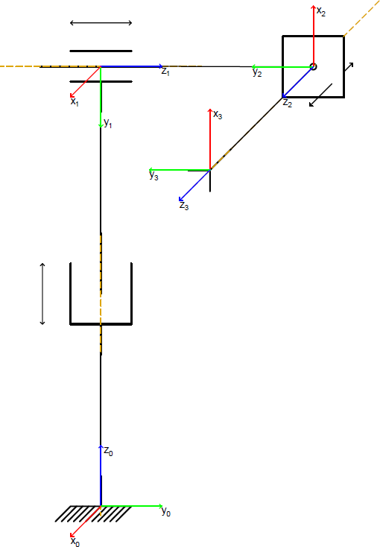

$$\left(\begin{matrix}0 & 0 & 1 & q_{3} \\ 0 & -1 & 0 & q_{2} \\ 1 & 0 & 0 & q_{1} \\ 0 & 0 & 0 & 1\end{matrix}\right)$$

# RRR Planare

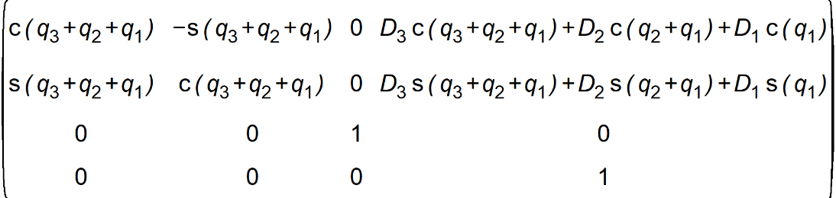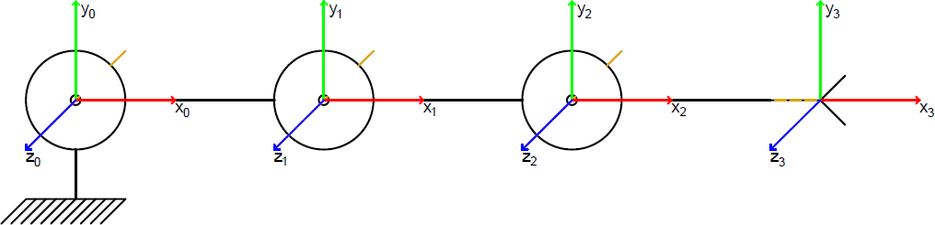

|  |  |  |  |  |
| --- | --- | --- | --- | --- |
|  | $$A_{z}\left(θ,d\right)$$ | | $$A_{x}\left(α,a\right)$$ | |
|  | **Θ** | **d** | **α** | **a** |
| R1 | Q1 | 0 | 0 | L1 |
| R2 | Q2 | 0 | 0 | L2 |
| R3 | Q3 | 0 | 0 | L3 |

# Cilindrico

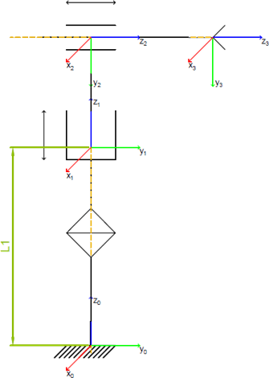

|  |  |  |  |  |
| --- | --- | --- | --- | --- |
|  | $$A_{z}\left(θ,d\right)$$ | | $$A_{x}\left(α,a\right)$$ | |
|  | **Θ** | **d** | **α** | **a** |
| R1 | Q1 | L1 | 0 | 0 |
| R2 | 0 | Q2 | -π/2 | 0 |
| R3 | 0 | Q3 | 0 | 0 |

$$\left(\begin{matrix}\cos{q_{1}} & 0 & -\sin{q_{1}} & -\sin{q_{1}} q_{3} \\ \sin{q_{1}} & 0 & \cos{q_{1}} & \cos{q_{1}} q_{3} \\ 0 & -1 & 0 & q_{2}+L_{1} \\ 0 & 0 & 0 & 1\end{matrix}\right)$$

# Scara

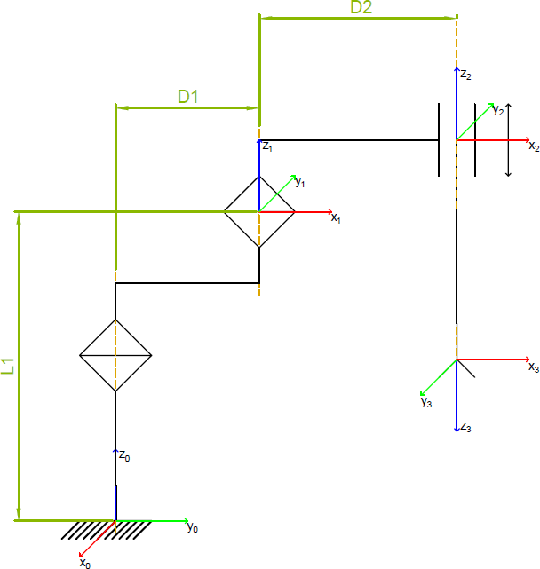

$$\left(\begin{matrix}\cos\left(q_{2}+q_{1}\right) & \sin\left(q_{2}+q_{1}\right) & 0 & D_{2} \cos\left(q_{2}+q_{1}\right)+D_{1} \cos{q_{1}} \\ \sin\left(q_{2}+q_{1}\right) & -\cos\left(q_{2}+q_{1}\right) & 0 & D_{2} \sin\left(q_{2}+q_{1}\right)+D_{1} \sin{q_{1}} \\ 0 & 0 & -1 & q_{3}+L_{2}+L_{1} \\ 0 & 0 & 0 & 1\end{matrix}\right)$$

|  |  |  |  |  |
| --- | --- | --- | --- | --- |
|  | $$A_{z}\left(θ,d\right)$$ | | $$A_{x}\left(α,a\right)$$ | |
|  | **Θ** | **d** | **α** | **a** |
| R1 | Q1 | L1 | 0 | D1 |
| R2 | Q2 | L2 | 0 | D2 |
| R3 | 0 | Q3 | Π | 0 |

# Sferico 1

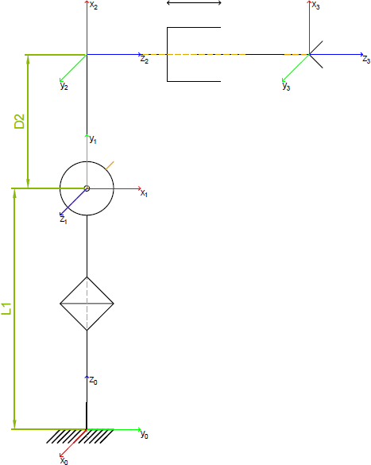

|  |  |  |  |  |
| --- | --- | --- | --- | --- |
|  | $$A_{z}\left(θ,d\right)$$ | | $$A_{x}\left(α,a\right)$$ | |
|  | **Θ** | **d** | **α** | **a** |
| R1 | Q1 | L1 | π/2 | 0 |
| R2 | Q2 | L2 | π/2 | D2 |
| R3 | 0 | Q3 | 0 | 0 |

$$\left(\begin{matrix}\frac{\cos\left(q_{2}+q_{1}\right)+\cos\left(q_{2}-q_{1}\right)}{2} & \sin{q_{1}} & \frac{\sin\left(q_{2}+q_{1}\right)+\sin\left(q_{2}-q_{1}\right)}{2} & \frac{\left(\sin\left(q_{2}+q_{1}\right)+\sin\left(q_{2}-q_{1}\right)\right) q_{3}+D_{2} \left(\cos\left(q_{2}+q_{1}\right)+\cos\left(q_{2}-q_{1}\right)\right)}{2} \\ \frac{\sin\left(q_{2}+q_{1}\right)-\sin\left(q_{2}-q_{1}\right)}{2} & -\cos{q_{1}} & -\frac{\cos\left(q_{2}+q_{1}\right)-\cos\left(q_{2}-q_{1}\right)}{2} & -\frac{\left(\cos\left(q_{2}+q_{1}\right)-\cos\left(q_{2}-q_{1}\right)\right) q_{3}+D_{2} \left(\sin\left(q_{2}-q_{1}\right)-\sin\left(q_{2}+q_{1}\right)\right)}{2} \\ \sin{q_{2}} & 0 & -\cos{q_{2}} & -\cos{q_{2}} q_{3}+D_{2} \sin{q_{2}}+L_{1} \\ 0 & 0 & 0 & 1\end{matrix}\right)$$

Sferico di Stanford

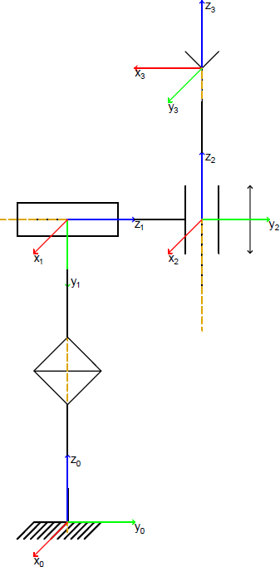

|  |  |  |  |  |
| --- | --- | --- | --- | --- |
|  | $$A_{z}\left(θ,d\right)$$ | | $$A_{x}\left(α,a\right)$$ | |
|  | **Θ** | **d** | **α** | **a** |
| R1 | Q1 | L1 | -π/2 | 0 |
| R2 | Q2 | L2 | π/2 | 0 |
| R3 | -π/2 | Q3 | 0 | 0 |

$$\left(\begin{matrix}\sin{q_{1}} & \frac{\cos\left(q_{2}+q_{1}\right)+\cos\left(q_{2}-q_{1}\right)}{2} & \frac{\sin\left(q_{2}+q_{1}\right)+\sin\left(q_{2}-q_{1}\right)}{2} & \frac{\left(\sin\left(q_{2}+q_{1}\right)+\sin\left(q_{2}-q_{1}\right)\right) q_{3}-2 L_{2} \sin{q_{1}}}{2} \\ -\cos{q_{1}} & \frac{\sin\left(q_{2}+q_{1}\right)-\sin\left(q_{2}-q_{1}\right)}{2} & -\frac{\cos\left(q_{2}+q_{1}\right)-\cos\left(q_{2}-q_{1}\right)}{2} & -\frac{\left(\cos\left(q_{2}+q_{1}\right)-\cos\left(q_{2}-q_{1}\right)\right) q_{3}-2 L_{2} \cos{q_{1}}}{2} \\ 0 & -\sin{q_{2}} & \cos{q_{2}} & \cos{q_{2}} q_{3}+L_{1} \\ 0 & 0 & 0 & 1\end{matrix}\right)$$

# Antropomorfo

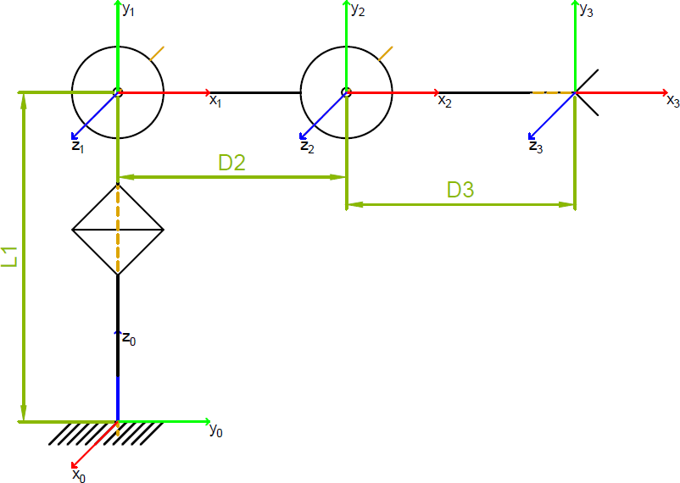

|  |  |  |  |  |
| --- | --- | --- | --- | --- |
|  | $$A_{z}\left(θ,d\right)$$ | | $$A_{x}\left(α,a\right)$$ | |
|  | **Θ** | **d** | **α** | **a** |
| R1 | Q1 | L1 | π/2 | 0 |
| R2 | Q2 | 0 | 0 | D2 |
| R3 | Q3 | 0 | 0 | D3 |

$$\left(\begin{matrix}\frac{\cos\left(q_{3}+q_{2}+q_{1}\right)+\cos\left(q_{3}+q_{2}-q_{1}\right)}{2} & -\frac{\sin\left(q_{3}+q_{2}+q_{1}\right)+\sin\left(q_{3}+q_{2}-q_{1}\right)}{2} & \sin{q_{1}} & \frac{D_{3} \left(\cos\left(q_{3}+q_{2}+q_{1}\right)+\cos\left(q_{3}+q_{2}-q_{1}\right)\right)+D_{2} \left(\cos\left(q_{2}+q_{1}\right)+\cos\left(q_{2}-q_{1}\right)\right)}{2} \\ \frac{\sin\left(q_{3}+q_{2}+q_{1}\right)-\sin\left(q_{3}+q_{2}-q_{1}\right)}{2} & \frac{\cos\left(q_{3}+q_{2}+q_{1}\right)-\cos\left(q_{3}+q_{2}-q_{1}\right)}{2} & -\cos{q_{1}} & \frac{D_{3} \left(\sin\left(q_{3}+q_{2}+q_{1}\right)-\sin\left(q_{3}+q_{2}-q_{1}\right)\right)+D_{2} \left(\sin\left(q_{2}+q_{1}\right)-\sin\left(q_{2}-q_{1}\right)\right)}{2} \\ \sin\left(q_{3}+q_{2}\right) & \cos\left(q_{3}+q_{2}\right) & 0 & D_{3} \sin\left(q_{3}+q_{2}\right)+D_{2} \sin{q_{2}}+L_{1} \\ 0 & 0 & 0 & 1\end{matrix}\right)$$

# Polso Sferico

|  |  |  |  |  |
| --- | --- | --- | --- | --- |
|  | $$A_{z}\left(θ,d\right)$$ | | $$A_{x}\left(α,a\right)$$ | |
|  | **Θ** | **d** | **α** | **a** |
| R1 | Q1 | 0 | -π/2 | 0 |
| R2 | Q2 | 0 | π/2 | 0 |
| R3 | Q3 | L3 | 0 | 0 |

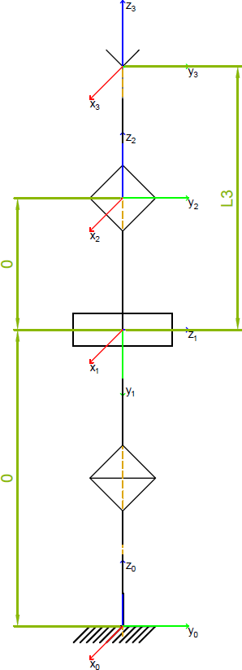

$$\left(\begin{matrix}\frac{\cos\left(q_{6}+q_{5}+q_{4}\right)+\cos\left(q_{6}+q_{5}-q_{4}\right)+\cos\left(q_{6}-q_{5}+q_{4}\right)+\cos\left(q_{6}-q_{5}-q_{4}\right)+2 \cos\left(q_{6}+q_{4}\right)-2 \cos\left(q_{6}-q_{4}\right)}{4} & -\frac{\sin\left(q_{6}+q_{5}+q_{4}\right)+\sin\left(q_{6}+q_{5}-q_{4}\right)+\sin\left(q_{6}-q_{5}+q_{4}\right)+\sin\left(q_{6}-q_{5}-q_{4}\right)+2 \sin\left(q_{6}+q_{4}\right)-2 \sin\left(q_{6}-q_{4}\right)}{4} & \frac{\sin\left(q_{5}+q_{4}\right)+\sin\left(q_{5}-q_{4}\right)}{2} & \frac{L_{6} \left(\sin\left(q_{5}+q_{4}\right)+\sin\left(q_{5}-q_{4}\right)\right)}{2} \\ \frac{\sin\left(q_{6}+q_{5}+q_{4}\right)-\sin\left(q_{6}+q_{5}-q_{4}\right)+\sin\left(q_{6}-q_{5}+q_{4}\right)-\sin\left(q_{6}-q_{5}-q_{4}\right)+2 \sin\left(q_{6}+q_{4}\right)+2 \sin\left(q_{6}-q_{4}\right)}{4} & \frac{\cos\left(q_{6}+q_{5}+q_{4}\right)-\cos\left(q_{6}+q_{5}-q_{4}\right)+\cos\left(q_{6}-q_{5}+q_{4}\right)-\cos\left(q_{6}-q_{5}-q_{4}\right)+2 \cos\left(q_{6}+q_{4}\right)+2 \cos\left(q_{6}-q_{4}\right)}{4} & -\frac{\cos\left(q_{5}+q_{4}\right)-\cos\left(q_{5}-q_{4}\right)}{2} & -\frac{L_{6} \left(\cos\left(q_{5}+q_{4}\right)-\cos\left(q_{5}-q_{4}\right)\right)}{2} \\ -\frac{\sin\left(q_{6}+q_{5}\right)-\sin\left(q_{6}-q_{5}\right)}{2} & -\frac{\cos\left(q_{6}+q_{5}\right)-\cos\left(q_{6}-q_{5}\right)}{2} & \cos{q_{5}} & L_{6} \cos{q_{5}} \\ 0 & 0 & 0 & 1\end{matrix}\right)$$